BREAKFAST MENU
SERVED DAILY FROM 9 AM – 11.15/9-11 SUNDAYS

The Duchy
A Warren’s sausage & two smoked back bacon, BBQ baked beans, fried or poached organic eggs, portobello mushroom, herb roasted tomatoes & Cornish hog’s pudding. Your choice of white or granary toast 16

The Garden

Grilled halloumi, two fried or poached organic eggs, BBQ baked beans, sliced fresh avocado, tomato and red pepper stew, sourdough toast V (VG option available) 15

Sausage bap/Bacon bap *

Local pork sausage, toasted ciabatta roll, butter OR Smoked back bacon, toasted white roll, butter 9

*make it vegetarian, fried egg and Cornish smuggler cheese, toasted ciabatta roll and butter
Duchy Shakshouka
Two organic poached eggs in a tomato and red pepper stew, herb roasted tomatoes, topped with Cornish feta and rocket, sourdough toast V (GF/VG/ options available) 15

Breakfast rosti

Potato rosti, two poached organic eggs, smoked streaky bacon Sauté courgetti, with smoked sweet chilli sauce GF (V option available) 14

Eggs Benedict *

Two poached organic eggs, glazed baked ham on a sourdough English muffin, hollandaise sauce 13

Eggs Royale *

Two poached organic eggs, smoked salmon on a sourdough English muffin, hollandaise sauce 14

The Duchy bun *

Seasoned local sausage patty, Cornish smuggler cheese, fried egg, smoked streaky bacon & brown sauce caramelised onions on a croissant roll 13

Baked sweet yoghurt

Baked Cornish yoghurt, topped with mango compote, nutty granola Duchy honey V (VG option available) 12
Add a side
Rosemary salted potato puffs VG/GF 5
‘Dressed’ potato puffs topped with sriracha, yoghurt and spring onions V 7

If you would like to make any additions to enhance your breakfast, please ask one of our team members.

BREAKFAST ROYALE MENU
served until 11:15AM / 11:00AM on Sundays
24hr Advance booking required
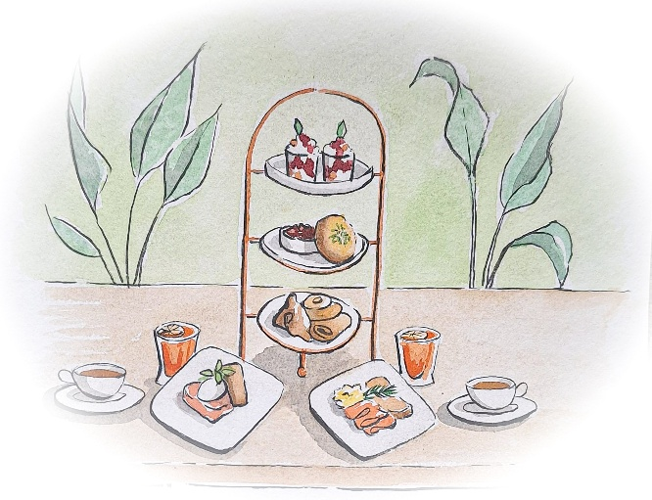

Our Breakfast Royale is the ultimate start to an indulgent morning.
Perfect for celebrations, special occasions or just a very special treat.

The three-tiered sharing event -
Toasted nut granola, blueberry compote, Cornish yoghurt & Duchy honey V
Mini Danish selection V
Aged cheddar cheese scone au gratin, apple & cider brandy chutney V
You will also choose from one of the following thyme potato rosti & Duchy organic egg dishes -
Poached egg, lime mashed avocado & Portobello mushroom GF/V
or
Scrambled egg & oak smoked salmon GF
or
Poached egg, honey-mustard glazed baked ham & hollandaise GF

Served with a glass of orange juice

Cornish tea or barista coffee

£23 per person

Why not go that extra mile and pair your special treat with one of our breakfast cocktails:
Peach Bellini / Matcha Ginger Sour / Raspberry Gin Iced Tea / or a non-alcoholic spritz
£26 per person

